|  |  |
| --- | --- |
| **NAMA**  **NIM**  **KELAS** | **: HENDRA USMAN**  **: D0221079**  **: F – INFORMATIKA** |

**FILE HTML:**

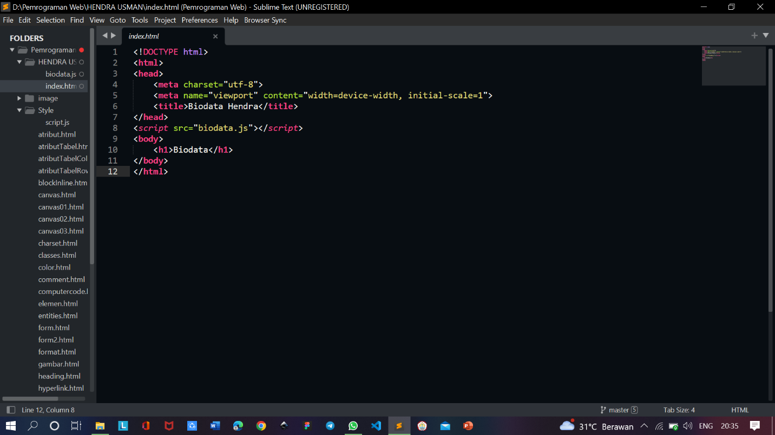

**FILE JAVASCIPT:**

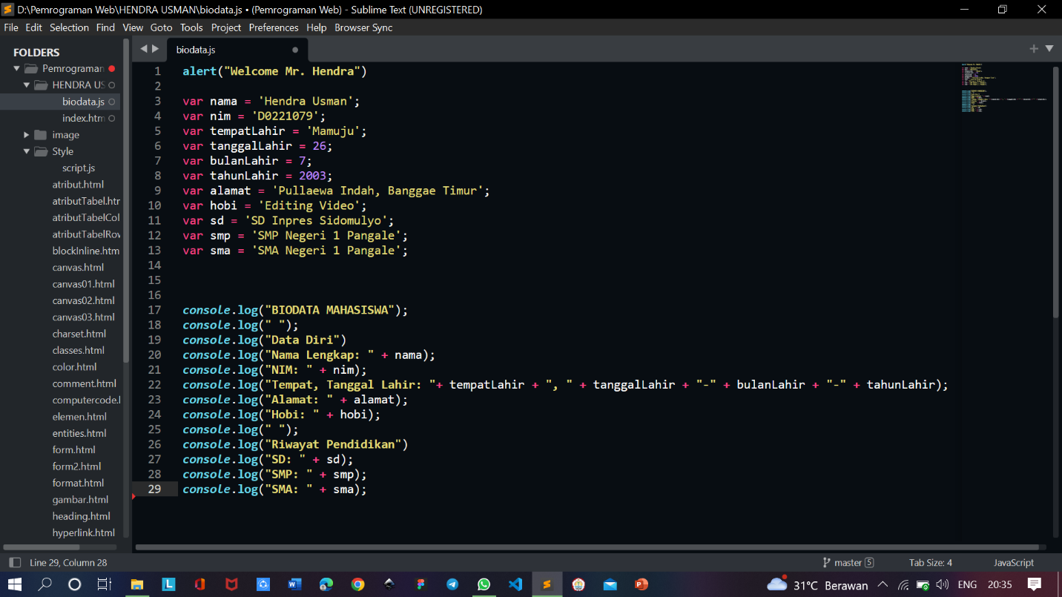

**OUTPUT:**

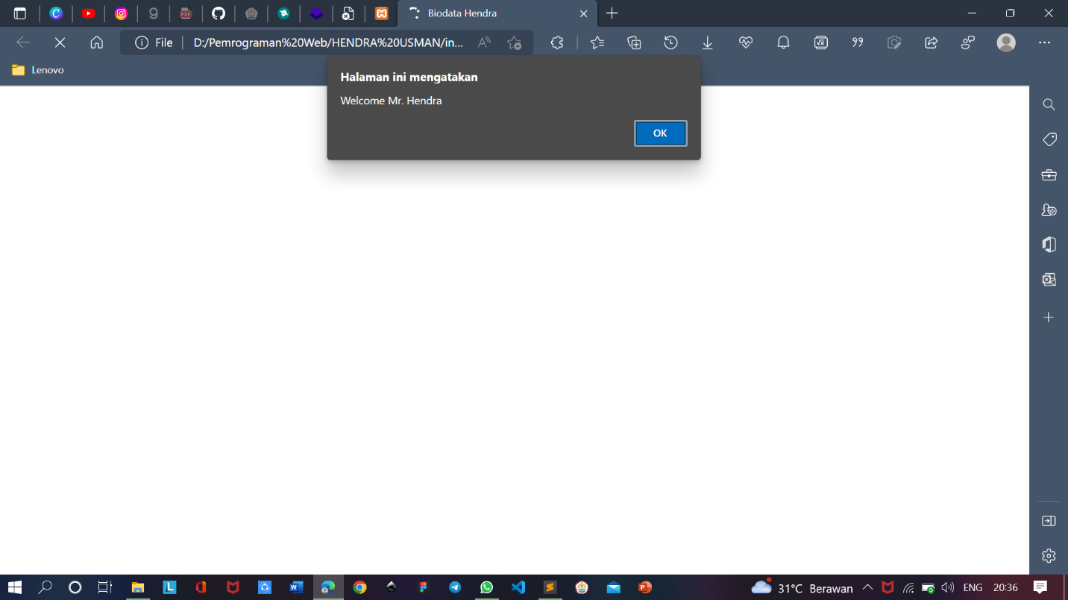

**OUTPUT (CONSOLE):**

